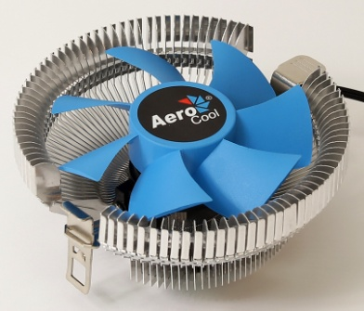
Product Overview:
PWM air cooling solution equipped with high efficiency fins and compact profile; works with most current Intel motherboard designs. Only for Intel chipset configurations.
Specifications

Model |  | Verkho i
Base Material |  | Aluminum
Dimension |  | 103 x 103 x 45mm
TDP(Thermal Design Power) |  | 90
Fan | Speed | 1200-2500 rpm
 | Connector | PWM 4-Pin
 | Dimension | 80 x 80 x 25mm
 | Bearing Type | Hydraulic Bearing
 | Started Voltage | 6V
 | Rated Voltage | 12V
 | Rated Current | 0.19 A
 | Power Consumption | 2.28 Watts (One Fan)
 | Air Pressure | 0.53-1.21 mm-H2O
 | Air Flow | 25.15-58.25 CFM
 | Noise | 12.2-29.7dBA
 | MTBF  (Mean Time Before Failure) | 60000 hrs.
Socket |  | LGA 1150/1151/1155/1156/775

Warranty

1 year

Features

- TDP (Thermal Design Power) up to 90W.
- Upgraded high efficiency fins for optimal thermal performance.
- Compact profile capable of mounting single 80mm fan configurations; works with most current Intel motherboard designs. Only for Intel chipset configurations.

Package Information

Product Name | Product Number | EAN CODE | UPC CODE
Verkho i | ACTC-NA10010.01 | 4710700950791
Carton Size ( L x W x H ) | 540 x 335 x 235 mm | Carton Weight | N.W 11.5 kg / G.W 12.8 kg
Retail Box Size ( L x W x H ) | 105 x 105 x 55 mm | Retail Box Weight | N.W 152 g / G.W 192 g
Carton Qty | 60 pcs | Pallet Qty | 3240(GP)/3600(HQ)

